Response of Crops Yields to BioMeStimulant MICRO FERTILE in Nigeria
By
Yusuf Dollah Fouad and Abubakar Hassan Inuwa
HarvestPlus Solution Nigeria
Background
The rapid human and livestock population increase implies that more agricultural land would be required for use in cultivation of crops and forages to feed the human and livestock population. However, agriculture will have to compete with other uses of land like housing, recreation, roads etc. Land is limited in availability and the same piece of land may have to be used continuously for cropping. Continuous use of land leads to depletion of the nutrient content and results in declining soil fertility. In the earlier times shifting cultivation was used, where farmers abandon land for many years to allow for soil fertility regeneration. However, that luxury is no longer feasible as such same land would have to be used continuously and farmers have to devise ways of artificially regenerating soil fertility or use means of organic or inorganic input to ensure adequate plant nutrition. For any crop, fertilizer is the most critical input for attaining the yield potential of improved high yielding varieties. The intensive farming and use of crop lands have resulted in nutrient mining and soil fertility depletion at an alarming rate, that has necessitated the need to add fertilizers and stimulant to augment the sustainable crop production. Traditionally, farmers use organic manure mainly of ruminant droppings, how the quantity needed and the bulkiness means enough quantity are mostly not applied. Improved agricultural practices recommend various classes of inorganic fertilizers. Continuous and exposes the soil to degradation which is brought about by loss of organic matter as a result of continuous cropping when solely applied repeatedly However recent studies have recommended a mixture of organic, inorganic and Stimulant fertilizers for optimum crop productivity as well as for soil health and fertility sustainability. The traditional organic and inorganic fertilizers are generally bulky and are now becoming more expensive to purchase, transport and apply on the fields and may sometimes pose a threat to soil health and ground water,. In recent times, inorganic fertilizers are also facing a serious threat of adulteration in the markets, which makes the use of organic fertilizers more necessary. For the conventional solid organic fertilizers, they are voluminous and require much labour for application. However, the benefit derivable from the use of solid organic fertilizers has not been attained fully mainly due to their large amount required in order to satisfy the nutritional need of the crops. In-view of these, bio stimulant foliar fertilizer becomes an alternative and complementary fertilizer product for use by farmers to ensure high grain and stover yields. Apart from improving yields of crops, these stimulants also correct the nutritional deficiencies in plants and has potential advantages over soil application thereby increasing the use efficacy where many other researches such as Hasddin et al. (2025) reported higher biostimulant efficiency through applications. In view of the above, HarvestPlus Solution in collaboration with ekolive evaluated BioStimulant (Microfertile) on important arable crops in Nigeria.
This report presents results from on-station and on-farm evaluations of BioStimulant (MICRO FERTILE) conducted across northern Nigeria during the 2025 rainy season. The study assessed effects on crop phenology, grain yield and stover yield across major cereals and legumes. Results demonstrate that BioStimulant application significantly accelerated flowering and maturity while improving grain yield, particularly in cereals, under both research and farmer-managed conditions.

Rationale
Agricultural intensification in Nigeria has led to severe nutrient mining and declining soil fertility. Traditional reliance on inorganic fertilizers alone has proven insufficient and sometimes detrimental to long-term soil health. BioStimulants represent an emerging class of inputs that enhance nutrient use efficiency, plant metabolism, and stress tolerance. This study responds to the need for climate-smart and cost-effective nutrient management solutions.
Aim
The aim of this experiment was to determine the effect of foliar bio Stimulant (MICRO FERTILE) on yields of crops in Northern Nigeria. With specific objectives of:
- Evaluate crop yield response to BioStimulant application
- Compare BioStimulant performance with conventional fertilizer practices.
- Identify crop-specific and location-specific responses.
- Validate station results under farmer-managed conditions.

Materials and Methods
Description of the Experimental Sites
The trials (On-Station and On-Farm) were conducted during the 2025 rainy season across several locations in Northern Nigeria State. Two on-station trials was conducted involving five crops (maize, sorghum, millet, groundnut and cowpea) at Bayero University Kano, Kano State, latitude 11.97691, longitude 8.41934 and Green Sahel Demonstration plot, Gumel, Jigawa State, latitude 12.63143, longitude 9.40638. The on-farm demonstrations was conducted on 15 locations (table 1) involving cowpea, millet, rice and maize in Kano and Jigawa states of Nigeria.
Experiments
A randomized complete block design was used for on-station trials, with four replications. Data collected included days to 50% flowering, days to maturity, plant height, grain yield, and stover yield. Harvest data were extrapolated to kg/ha for analysis.
The two on-station experiments were set-up with five different crops and varieties (Maize (SAMMAZ 52), Sorghum (SAMSORG 45), Millet (Chakti “LCIC 5”), Cowpea (SAMPEA 14) and Groundnut (SAMNUT 24). Each plot is 5 x 3 meter (5 meter 4 rows) and replicated 4 times in each of the two locations. The main plot was made of four rows spaced 75cm between rows 5m long. The each plot received the fertiliser at recommended rate.
Four treatments were applied as, Biostimulant only, conventional fertilizer based on crop, Biostimulant and Conventional Fertilizer and no treatment. The data is collected on vigour, stand count, days 50% flowering, days to maturity, plant height, panicle and pod weight, grain weight and stalk weight. The BioStimulant was sprayed on all crops in the required treatment three times at an interval of three weeks. At harvest two mid rows were harvested separately for each treatment. The harvest were dried and threshed. The grain and dried stover were weighed and recorded. The weights were extrapolated to yield kg/ha.
The on-farm demonstration is conducted in the farmer plots during the 2025 rainy season between June to November, fourteen plots were used as supervised by the extension staffs and the biostimulant were sprayed 3 times in 10 rows of 10 meter plot and remaining of the farm as control. During harvest, we have harvested 2 rows (1.5 x 10 meters) of the treated plot and the control. The harvest were dried and threshed. The grain and dried stover were weighed and recorded. The weights were also extrapolated to yield kg/ha.

Table 1. Locations of On-farm trials in Kano and Jigawa States
S/n | Name | State | Location (LGA) | Longitude | Latitude
1 | Abdulkarim Maishanu | Jigawa | Buji | 9.76903 | 11.58125
2 | Garba Musa Limawa | Jigawa | Dutse | 9.33038 | 11.74666
3 | Naziru Umar | Jigawa | Gumel | 9.22723 | 12.35655
4 | Nasiru M. Yusuf | Jigawa | Kila | 9.78716 | 11.32984
5 | Hafsat Dan Abba | Jigawa | Kiri Kasamma | 10.14165 | 12.54864
6 | Hamisu B. Muhammad | Jigawa | Jahun | 9.62966 | 12.17367
7 | Dahiru Ibrahim | Jigawa | Gumel | 9.40593 | 12.64008
8 | Ibrahim Nagodi | Kano | Ungogo | 8.43740 | 11.99062
9 | Bashir Boyi | Kano | Bichi | 8.23302 | 12.20655
10 | Bayero Sani | Kano | Tofa | 8.41934 | 11.97691

Results

On-Station
Table 2 shows the response of On-station trial, the grain yield in response to BioStimulant only foliar spray indicated higher grain yield in Cowpea 920 kg/ha, while the BioStimulant and Conventional Fertilizer indicated higher grain yield on groundnut (1,260 kg/ha) and maize (4,733 kg/ha), and conventional fertilizer used indicated higher grain yield in millet (1,533 kg/ha) and sorghum (2,733 kg/ha) respectively. The bioStimulant foliar spray increase grain yield by up to 50% in cowpea, the combination of BioStimulant and conventional fertilizer increases grain yield by 3 – 8%.
2. Grain Yield (Kg/Ha) of On-Station Trials
Treatment/Crop | Cowpea | Groundnut | Maize | Millet | Sorghum | Mean
BioMeStimulant | 920 | 1247 | 2533 | 1267 | 2333 | 1664
BioStimulant + Conventional | 873 | 1260 | 4733 | 1400 | 2400 | 2121
Control | 613 | 1167 | 2333 | 1267 | 2200 | 1576
Conventional | 833 | 1233 | 3933 | 1533 | 2733 | 2033
Mean | 810 | 1227 | 3383 | 1367 | 2417 | 1849

1. Grain Yield (kg/ha)
Although BioStimulant + Conventional produced the highest mean grain yield, variability across crops meant the overall treatment effect was not statistically significant. Maize showed a very strong numerical response (up to 4733 kg/ha), but inconsistent responses in other crops reduced statistical power. BioMeStimulant 1664 kg/ha, BioStimulant + Conventional 2121 kg/ha, Control, 1576 kg/ha and Conventional 2033 kg/ha.
Grain yield was primarily crop-driven rather than treatment-driven in this experiment. Biostimulants showed numerical advantages, especially in cereals, but responses were not consistent enough across all crops to achieve statistical significance.

Table 3. Mean grain yield by crop of On=Station Trials
Crop | Mean Yield (kg/ha)
Cowpea | 810
Groundnut | 1227
Maize | 3383
Millet | 1367
Sorghum | 2417

2. Days to Maturity
BioStimulant + Conventional shortened crop duration by 6–7 days compared to Control. The effect was consistent across crops, especially in maize and millet. Earlier maturity is a climate-smart advantage, reducing exposure to terminal drought and enabling flexible planting or relay cropping. Vegetative growth, but rather improved physiological efficiency.

3. Stover Yield (kg/ha)
All improved nutrient treatments increased stover yield relative to the Control. However, similar to grain yield, high variability among crops masked treatment effects. Mean stover yield by treatment indicated that BioMeStimulant, BioStimulant + Conventional, Control and Conventional treatments obtained, 2809 kg/ha, 2874 kg/ha, 2428 kg/ha and 2820 kg/ha respectively.
Table 4. Stover Yield (Kg/Ha) of On-Station Trials
Treatment/Crop | Cowpea | Groundnut | Maize | Millet | Sorghum | Mean
BioMeStimulant | 1987 | 2481 | 2487 | 2874 | 4215 | 2809
BioStimulant + Conventional | 2087 | 2455 | 2499 | 2889 | 4439 | 2874
Control | 1458 | 1927 | 2289 | 2576 | 3888 | 2428
Conventional | 1998 | 2481 | 2475 | 2800 | 4345 | 2819
Mean | 1883 | 2336 | 2438 | 2785 | 4222 | 2733

Conclusion
Phenology was most responsive to biostimulants, significant reductions in days to flowering and maturity. Yield responses were crop-specific, strong numerical gains in maize and sorghum. Plant height remained balanced under biostimulant treatments. Climate-smart benefit include earlier maturity without yield penalty is valuable under rain-fed conditions. Biostimulants improved efficiency, not just biomass, Suggests improved partitioning and stress tolerance. Biostimulant application significantly accelerated flowering and maturity across crops, while producing numerically higher grain and stover yields, particularly in cereals without excessive vegetative growth, indicating improved physiological efficiency under rain-fed conditions.

On-Farm Demonstrations

On-farm validation trials were conducted across two states (Jigawa and Kano), covering some LGAs, communities and four crops (millet, cowpea, rice, maize). Treatments compared BioStimulant against Control under farmer-managed conditions.

1. Effect on Crop Maturity
In most locations, BioStimulant either maintained or slightly reduced days to maturity. Notable reductions is Rice in Buji, BioStimulant 5 days earlier and Maize in Dausayi, BioStimulant 7 days earlier. Earlier or unchanged maturity under BioStimulant indicates no delay in crop cycle, with clear climate-smart advantages by reducing exposure to terminal drought and allowing better timing flexibility.

2. Grain Yield Response (kg/ha)
Across all crops, BioStimulant application increased grain yield compared with the Control (table 2). Average grain yield across treatments was highest in rice (6000 kg/ha), followed by maize (4834 kg/ha), millet (1736 kg/ha) and cowpea (1614 kg/ha). Rice showed the largest absolute and relative yield response to the BioStimulant. Maize also responded strongly, indicating high responsiveness to biostimulant application. Even the lowest response (cowpea) still showed a meaningful yield advantage. Crop × Treatment interaction (0.032) indicates a significant interaction, meaning the BioStimulant effect varied by crop.
Consistent grain yield advantage of BioStimulant across all crops and locations. Yield gains were largest in cereals (rice, maize, millet). Even under farmer conditions, yield increases ranged from 10% to over 57%, demonstrating robust field performance.

Table 5. Crop-wise yield gains under BioStimulant
location | Crop | BioStimulant | Control | % Increase
Dutse | Millet | 1520 | 1493 | 1.8
Kiri Kasamma | Millet | 2800 | 1867 | 50.0
Gumel | Millet | 1600 | 1133 | 41.2
Jahun | Cowpea | 2133 | 1933 | 10.3
Kiri Kasamma | Cowpea | 1733 | 1467 | 18.1
Gwaram | Cowpea | 1467 | 947 | 54.9
Buji | Rice | 7333 | 4667 | 57.1
Ungogo | Maize | 6000 | 4000 | 50.0
Ungogo | Maize | 5333 | 4000 | 33.3

3. Stover Yield Response (kg/ha)
BioStimulant also increased stover yield (table 3), but the magnitude of response was smaller and more uniform. Cowpea and millet showed relatively better stover response than maize. Maize stover yield was only marginally affected, suggesting the BioStimulant primarily favored grain partitioning rather than biomass accumulation.
BioStimulant generally increased stover yield, but responses were more variable than grain yield. Millet in Gumel +40.8%, Rice in Buji +9.4% and Maize in Ungogo +23.8%. Increased biomass under BioStimulant enhances dual-purpose value (grain + fodder). Variability reflects differences in crop type and local management, typical of on-farm trials.

Table 6.
Crop | BioStimulant | Control | % Increase
Cowpea | 2711 | 2356 | 15.1%
Maize | 2933 | 2867 | 2.3%
Millet | 2800 | 2502 | 11.9%
Rice | 4667 | 4267 | 9.4%

Conclusion
Higher grain yield even where stover increase was modest indicates improved harvest index and assimilate partitioning, not just vegetative growth. This supports earlier station results that BioStimulants improve physiological efficiency, not plant “lushness”. BioStimulant consistently increased grain yield across crops, states, and communities. Yield gains were strongest in cereals, especially rice and maize. Earlier or unchanged maturity confirms climate-smart suitability. Improved grain–biomass balance suggests better nutrient uptake and stress tolerance. Results under real farmer conditions validate station trial findings.
The consistency between on-station and on-farm results strengthens confidence in the agronomic value of BioStimulant. Improved physiological efficiency, earlier maturity, and higher grain yield align with reported mechanisms of biostimulants in literature. The BioStimulant significantly enhanced grain yield, with crop-specific responses, particularly strong in rice and maize. Effects on stover yield were positive but less pronounced, and not crop-dependent. The results suggest that the BioStimulant improves harvest index and assimilate partitioning toward grain, rather than simply increasing vegetative growth.
On-farm validation across Jigawa and Kano States demonstrated that BioStimulant application consistently increased grain yield across millet, cowpea, maize, and rice, with yield advantages ranging from 10% to over 50% under farmer-managed conditions. Either BioStimulant treatments maintained or reduced days to maturity, offering climate-smart benefits without delaying crop cycles. Improvements in grain yield were achieved without excessive vegetative growth, indicating enhanced physiological efficiency and assimilate partitioning. These results confirm the agronomic robustness and scalability of BioStimulant use in rain-fed cereal and legume systems of northern Nigeria.

Recommendations
BioStimulant (MICRO FERTILE) demonstrated strong potential to enhance crop productivity under both research and farmer conditions. It is recommended for wider scaling, particularly in cereal-based systems, alongside farmer training and further multi-season validation.

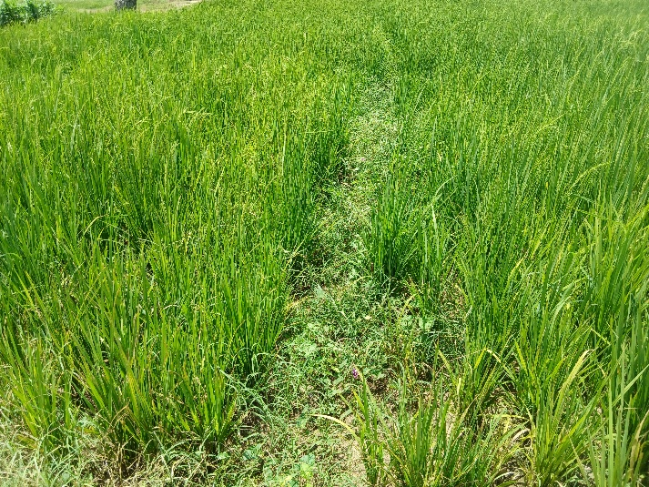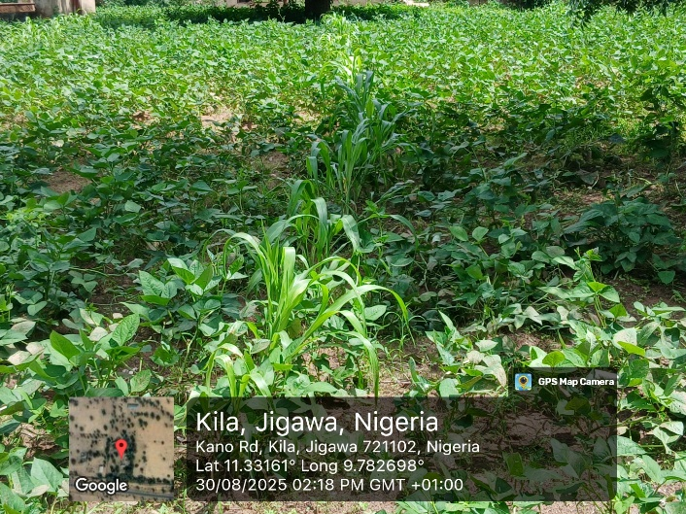
Figure 1. Some On-farm Demonstrations Plots in Different Locations

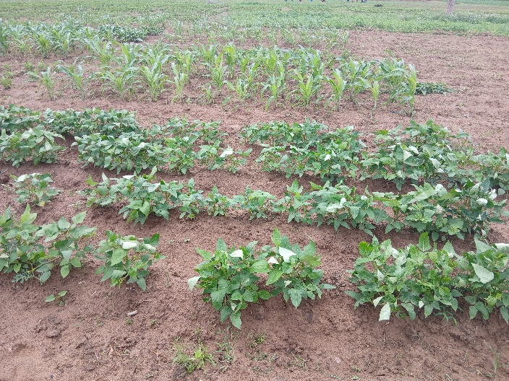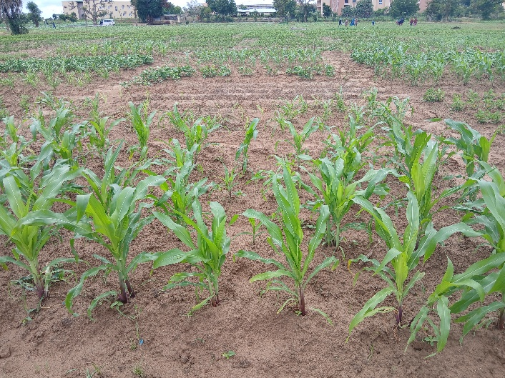
Figure 2. Some Pictures from On-Station at Bayero University
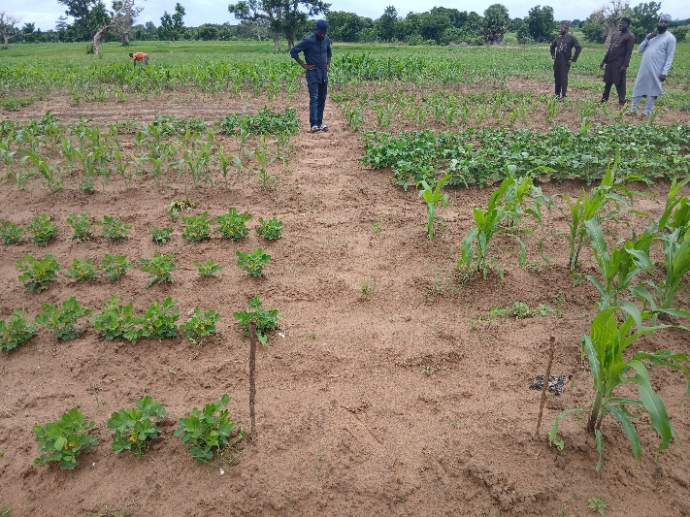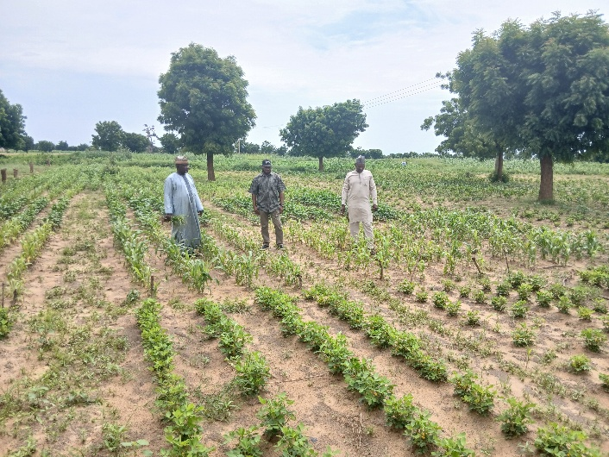
Figure 3. Some Pictures from On-Station at Vegetative state in Bayero University Kano and NTA Gumel
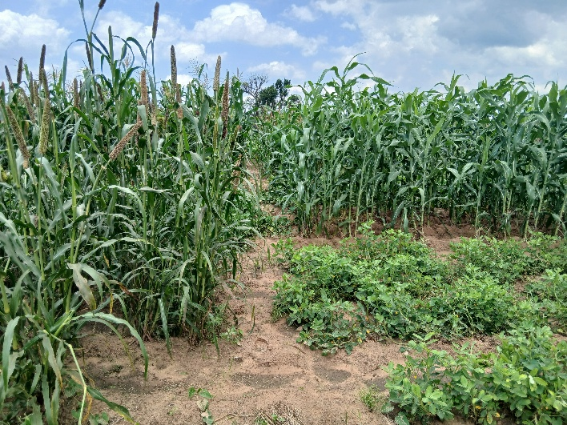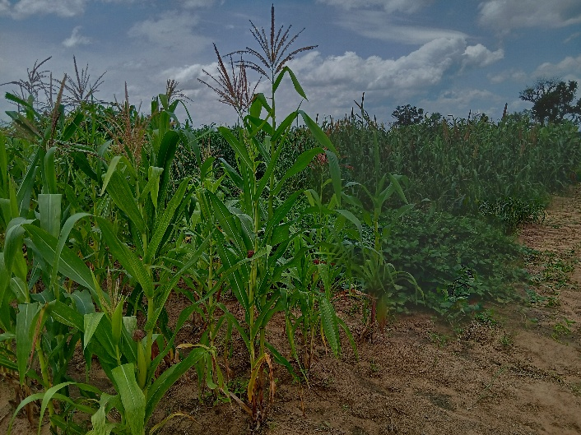
Figure 4. Some Pictures from On-Station at reproductive stage in Bayero University Kano

